Create 2 S3 buckets in 2 different regions. Upload one file in one S3 bucket region. Transfer the file into another region.

1. Search S3 in search bar and click on create bucket

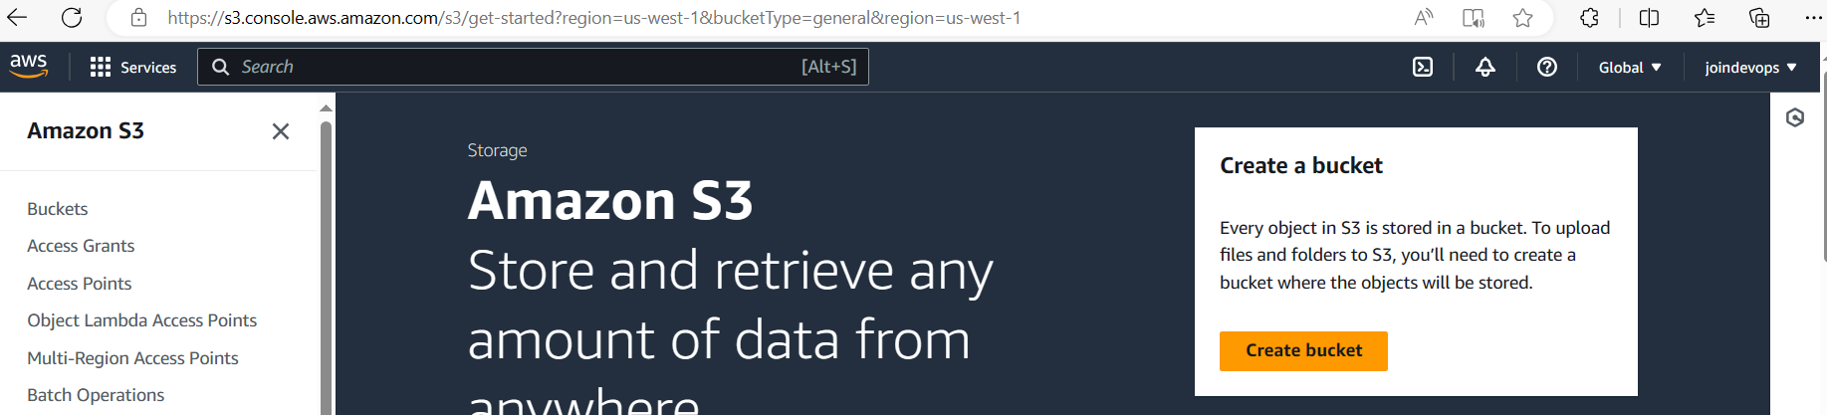

1. Create one S3 bucket in California region

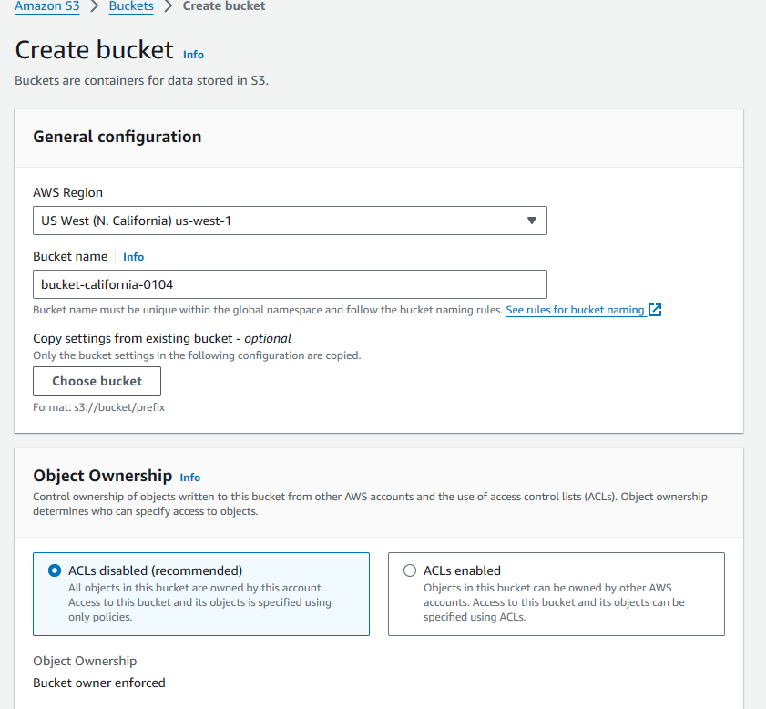

1. Click on enable in versioning

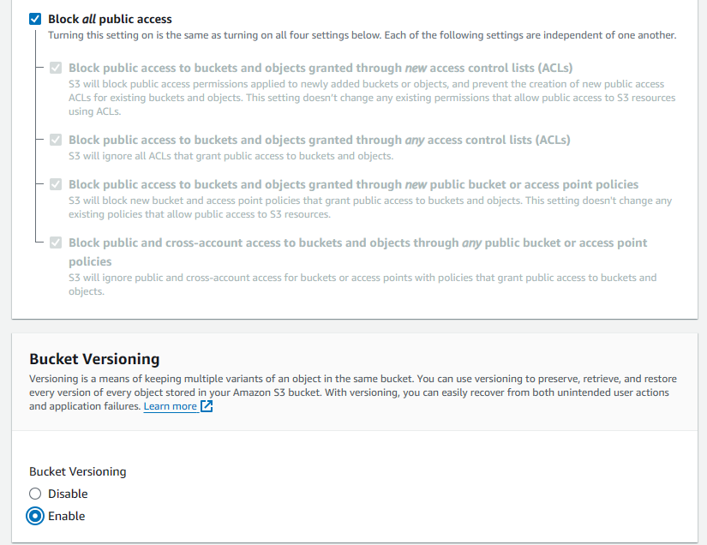

1. Click on create bucket

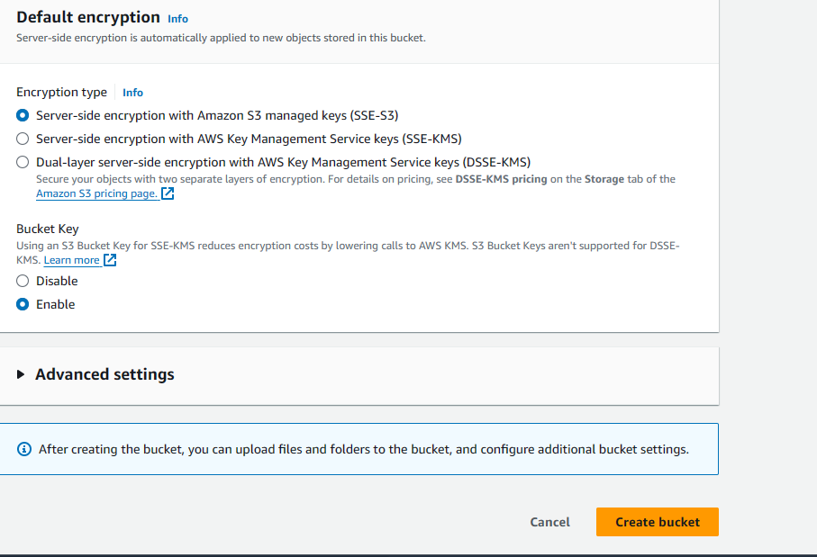

1. Bucket will be created.
2. Create another bucket in oregan region

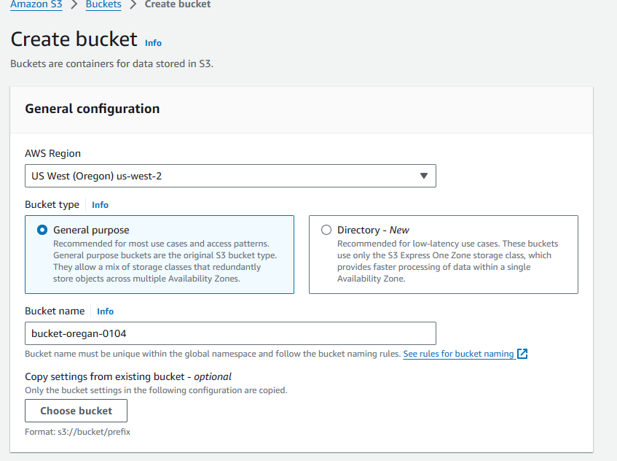

1. Click on enable in versioning

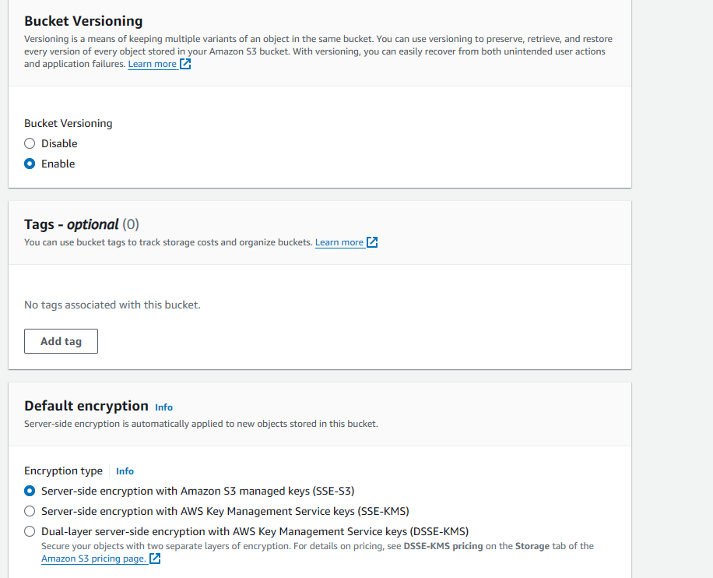

1. Click on create bucket

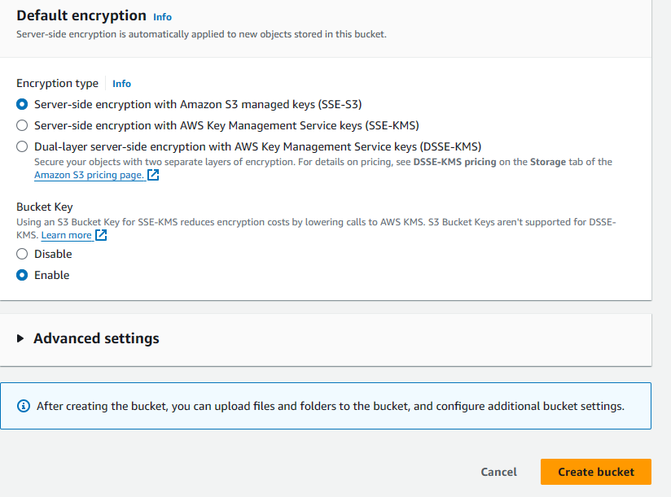

1. Click on California bucket name

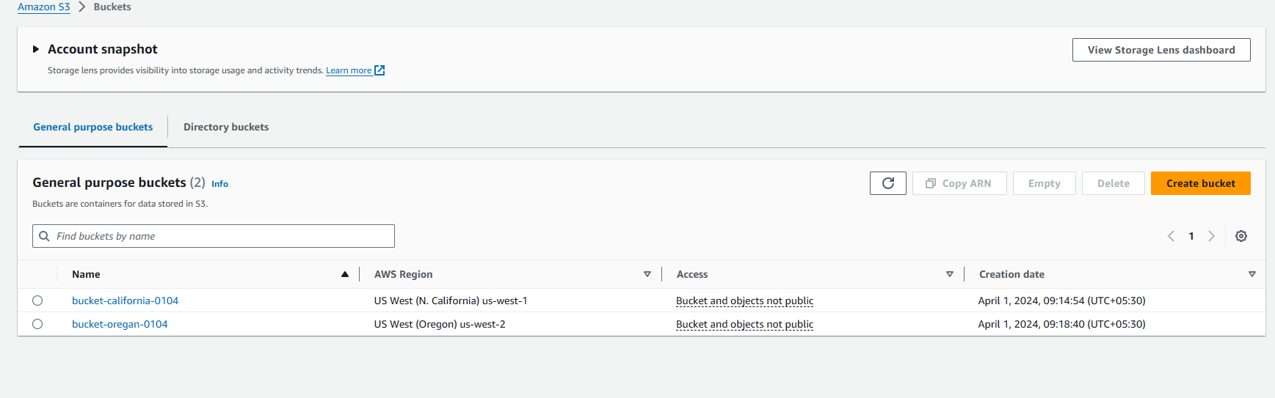

1. Click on upload button

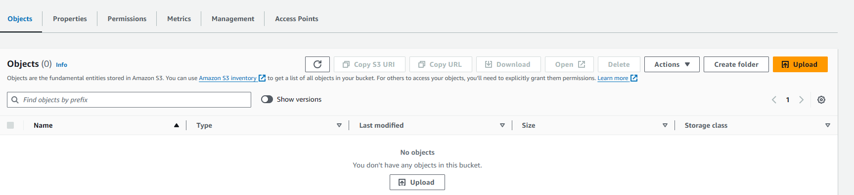

1. Click on add files and upload the text file case-study-1.txt file

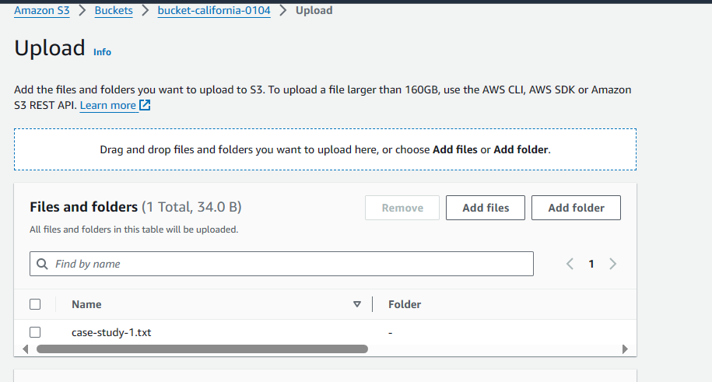

1. Click on upload button.
2. Click on management tab , In replication rules click on “create replication rule”

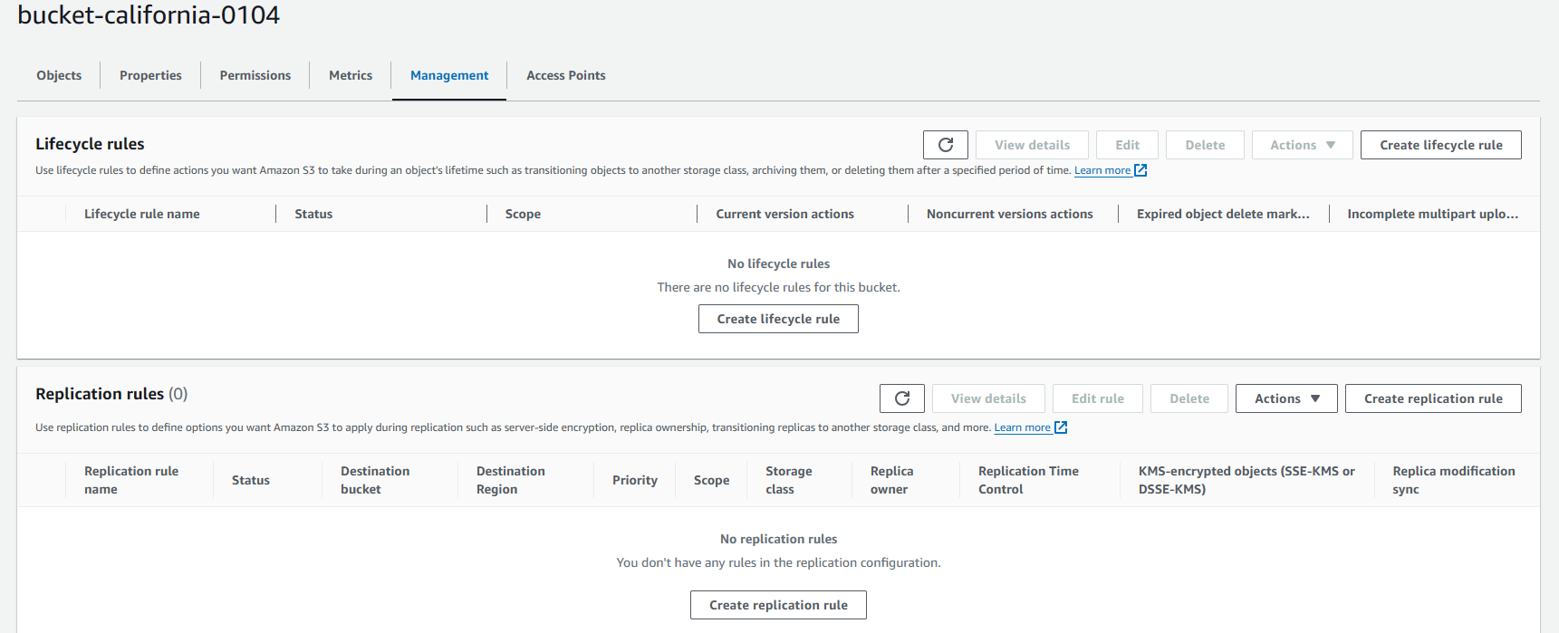

1. Give replication rule name

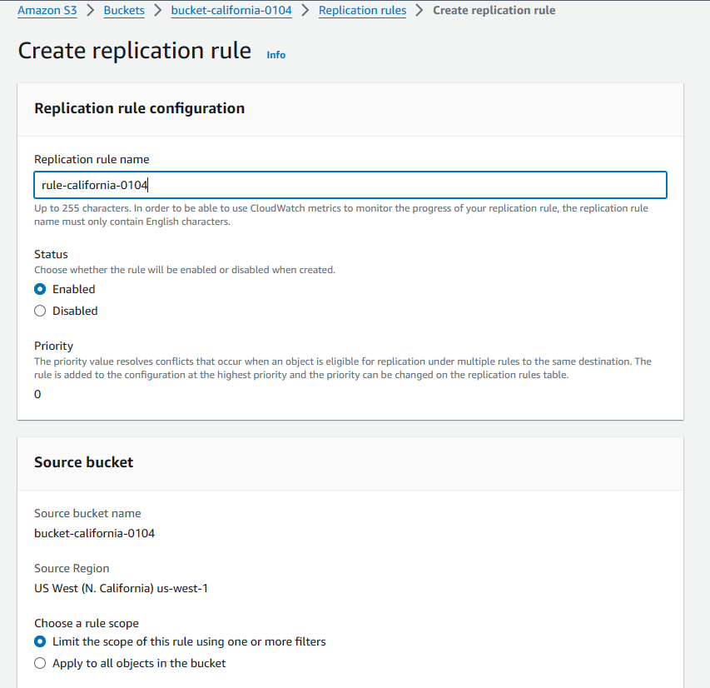

1. Click on “browse S3”

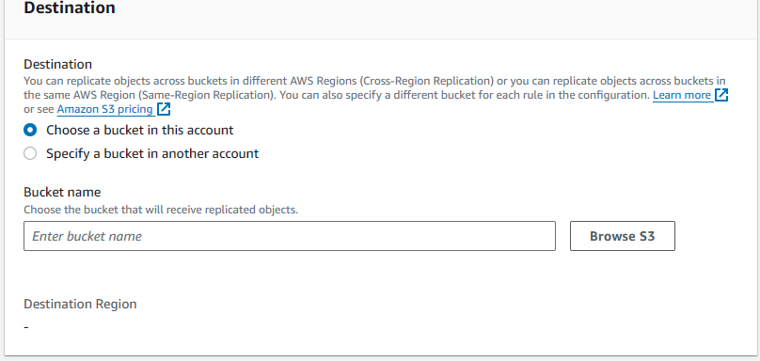

1. Choose the another S3 bucket region in destination and click on choose path

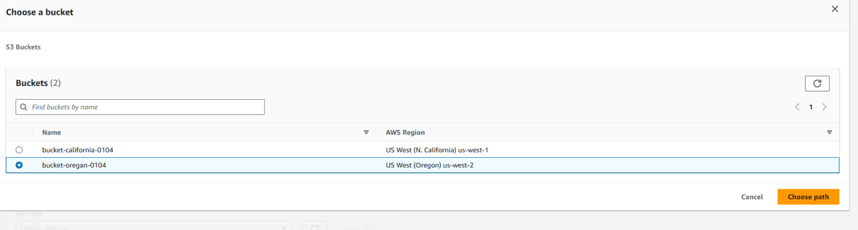

1. Give filter type prefix as file name

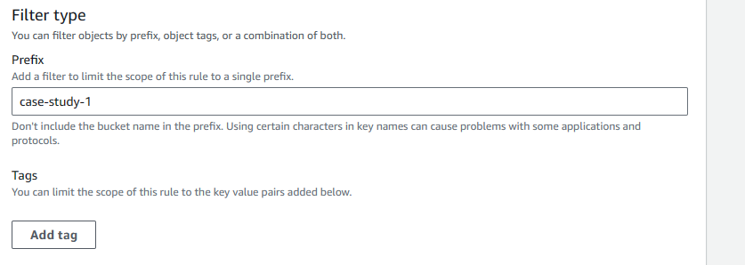

1. Click on create IAM role

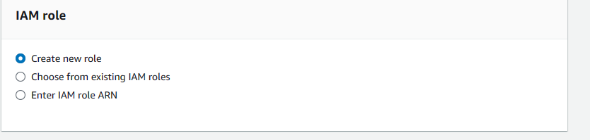

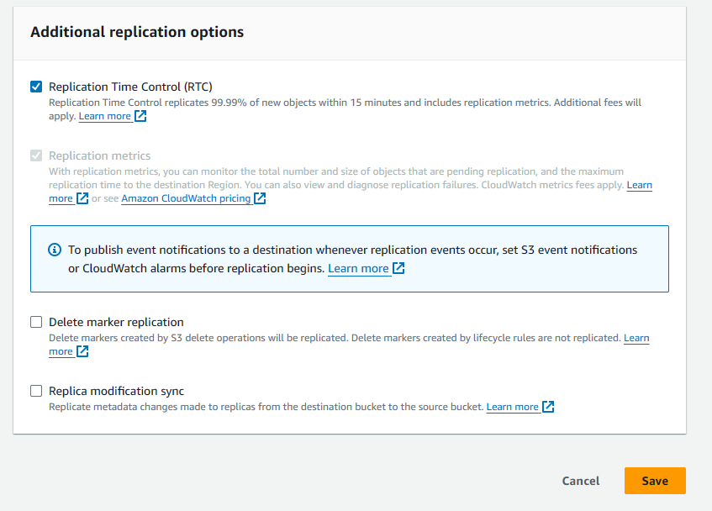

19 a pop up will be arised click on submit

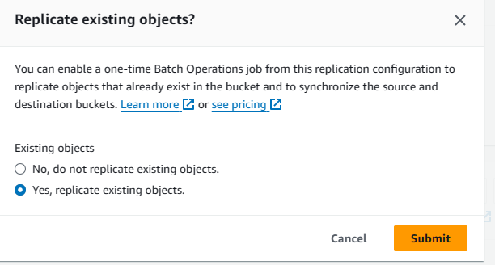

20 give destinatinpath in “Completion report destination” and click on save

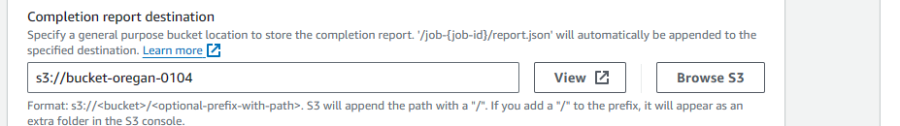

21. Job will be created.

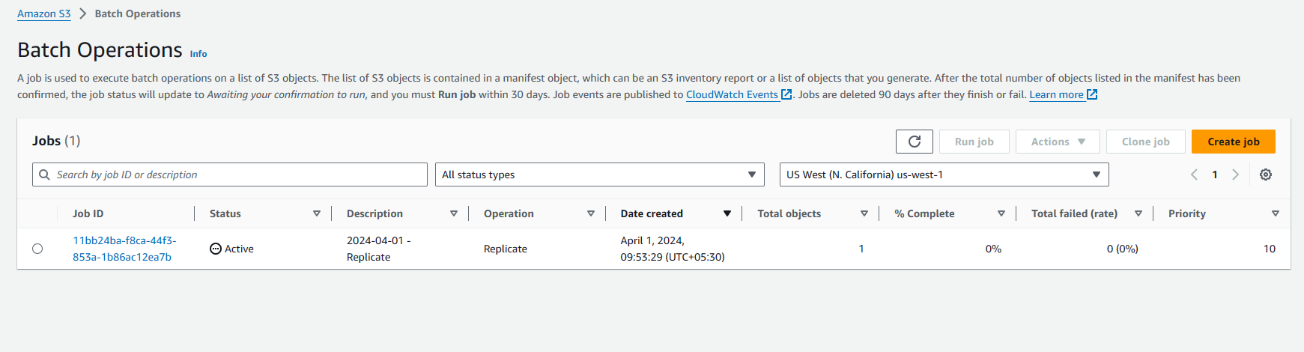

22. go to another region (oregan) and check if the file is uploaded

